**Special Newsletter…**

**Reports**

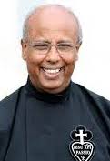Here in Rome, the General Chapter devoted two days to reports from the General (Fr Joachim), the General Econome (Fr Antonio) and the six Configurations, representing Passionists around the world.Erick sent Joachim’s report last week, so there is no need to repeat that, other than to highlight from the summary a consistent decline in the numbers of Congregation’s personnel. It is expected that this downward trend (principally in the northern hemisphere) will continue, with religious ageing and retiring and with deaths and departures. Many houses and presences will have to be evaluated for closure, communities will need to be more concentrated and consolidated, and ministries limited or renewed.

In the last six-year General administration term, two Provinces in northern Europe: St. Gabriel’s Belgium and St. Joseph’s England/Wales/Sweden were suppressed. Both were unable to provide personnel for leadership and had too few members. Belgium is now the responsibility of the Superior General, while the St Joseph’s personnel chose to be incorporated into St. Patrick’s Province (Ireland and Scotland).

An area of concern is the quite significant number of religious who have requested to leave the Congregation They comprise mainly younger to middle-aged ordained priests, mostly requesting incardination into a diocese. There are multiple reasons for these moves such as the demands of community life, issues of poverty, authority issues, strained relationships with confreres, the desire to be in charge and not feeling they belong or have been accepted. For others, it is seeing a slow ‘death’ of the institute with no clear meaningful hope for the future. Some have been captured by *“spiritual worldliness”* which Pope Francis warns about, and which promotes individualism, self-centredness, independence, and clericalism.

The General Econome reported on the state of the Congregation’s finances, highlighting the high costs of solidarity to support the growing area of the Congregation, the challenges involved in trying to sell some of the very big houses and the huge maintenance costs of the house here in Rome. With time for questions, that took about an hour and a half!

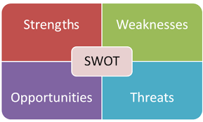The Configuration reports were asked to be presented using the SWOT model and each participant was asked afterwards to contribute on a small sticky note, issues that fit into the four quadrants.

**The Configurations are**:

**MAPRES**: The Configuration of Mary Presented In The Temple which includes Italy, France and Portugal and related mission territories.

**CCH**: The Configuration of Charles Houben which includes Ireland, England, Scotland, Wales, Germany, Poland, Belgium, the Czech Republic, Ukraine, Holland, Sweden and related mission territories;

**CJC**: The Configuration of Jesus Crucified which includes Mexico, Brazil, the United States, Argentina, Puerto Rico, the Dominican Republic, Haiti, Canada, Uruguay, Paraguay and related mission territories

**PASPAC**: The Configuration of the Passionists in Asia Pacific which includes Australia, New Zealand, Papua New Guinea, the Philippines, Korea, Japan, Indonesia, India, China and Vietnam and related mission territories

**CPA**: The Configuration of the Passionists of Africa, which includes Kenya, Tanzania, the Republic of the Congo, South Africa, Botswana, Zambia and related mission territories

**SCOR**: The Configuration of the Sacred Heart which includes Spain, Peru, Colombia, Ecuador, Venezuela, Chile, Panama, Honduras, Guatemala, Cuba, El Salvador, Bolivia, Nicaragua and related mission territories.

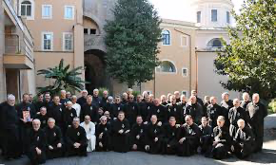**The MAPRES Configuration** which has become one Province, has 4 Areas: NORTH (France and Italy), CENTRE (Italy, Bulgaria), SOUTH (Italy), and WEST (Portugal-Angola). There are 349 religious with an average age of 66, 24 students and 5 novices. There are 50 communities. In the years 2015-2024 there have been 48 men professed, 25 ordained, 108 deaths and 62 men have left the Congregation.

**The SCOR (Sacred Heart) Configuration** has also become one Province. The Configuration includes Spain, Peru, Colombia, Ecuador, Venezuela, Chile, Panama, Honduras, Guatemala, Cuba, El Salvador, Bolivia, Nicaragua and related mission territories. There are 287 professed (113 fewer than in 2015). There are 20 professed students, 5 novices and 15 postulants The religious live in 13 countries, with 45 active houses. One-third of the men are aged over 80 and there have been a significant number of departures from the Congregation in recent years.

Over the past eleven years, these two large Configurations have suffered big losses of personnel to their workforce, as the result of death, departures and ageing. What will be their situation in six years time?

**The Configuration of Charles Houben** includes Ireland, England, Scotland, Wales, the Netherlands, Germany, Poland, Belgium, the Czech Republic, Ukraine, Holland, Sweden and related mission territories. As noted, the Belgium Province has been closed and the remaining brothers come now under the direct authority of the General. England has joined Ireland and Scotland, and the last community in Wales has been closed. The community in Highgate, London is now under the direct authority of the General. The Netherlands is like to join Ireland and Scotland next year. This an ageing Configuration.

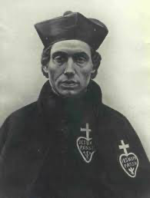There are a total of 125 religious with an average age of 64. There are 12 professed students and 5 novices. The patron, Charles Houben was born in the Netherlands, studied for the Passionists in Belgium, appointed to work in England after his ordination and later to Ireland, where he died in 1893. He was canonised in 2007.

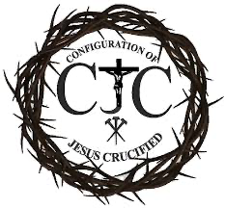The **Configuration of Jesus Crucified** is divided into two zones. The northern zone includes Provinces of St. Paul of the Cross and Holy Cross (USA), Canada, Jamaica/West Indies, the Dominican Republic, Haiti, Puerto Rico, Mexico. The Southern Zone: includesthe Provinces of Gethsemane (Brazil, Mozambique, Argentina, Paraguay and Uruguay) and Exaltation of the Holy Cross (Brazil).

There are 311 members, 36 professed students, 23 novices, 11 postulants and 5 aspirants. This is a very large Configuration working in different languages.

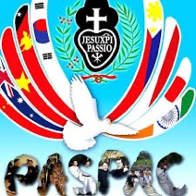**The PASPAC Configuration** includes Australia, New Zealand, Papua New Guinea, the Philippines, Korea, Japan, Indonesia, India, China and Vietnam and related mission territories. It is the youngest and largest configuration comprising 434 religious, 24 novices and 99 postulants and it covers 40% of the world’s population.

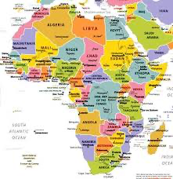**The CPA Configuration has four areas.**

Kenya has 65 finally professed members; Tanzania has 36 finally professed members. Congo DRC has 52 finally professed members. Botswana, Zambia and Sth Africa have 23 finally professed members. The region has 46 professed students, 16 novices and 40 junior students. The Configuration is young, and their biggest struggle is economic.

It is clear that on present trends, the future of the professed Congregation lies in Asia and Africa.

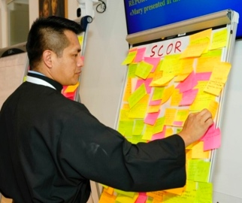Five boards were set up on Wednesday and as mentioned, participants were invited to use different coloured sticky notes to indicate from what they had heard, the strengths, weaknesses, opportunities and threats (or challenges) each Configuration faced. These were collected, collated and made available electronically to each participant. This information was helpful when we considered the issue of Configurations on Saturday morning. The Chapter will have to formally ‘assess’ the Configurations as a permanent feature of governance, abandon them or extend the period of experimentation.

**Inner Life**

Our Moderator, Fr Yago proposed that 7 attitudes were important in considering the 5 areas the Chapter agenda will be based on. These attitudes are

1. **Conciseness** (attention to brevity and clarity).

2. **Prioritization**.

3. **Respect**: appreciating each participant's input.

4. **Open-mindedness**: being receptive to new ideas to foster collaboration

5. **Collaboration** (willingness to work together).

6. **Systemic thinking** (a mindset that can grasp the interdependence of all Agenda issues).

7. **Developing a holistic perspective** (seeing the interconnectedness among the Agenda items).

We were asked to connect the 7 attitudes with the 5 Chapter themes (Inner Life, Belonging Leadership, Configurations and New Ministries) and then to prioritize them. This was done through sharing at our tables of 6 (which are language based). The similarity of the tables prioritising was impressive.

The Chapter members were then invited to work in our wider language groups (of 10 members). These were in turn divided into two blocks: one worked on the theme of “inner life” and the other on “belonging”. I was designated to the ‘belonging’ group.

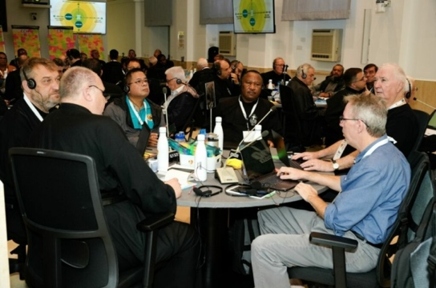Each group was asked to take up the task in a synodal way (10 minutes silence; 30 minutes @ 3 minutes each) personal reflection without comment or interruption; 5 minutes silence; 30 minutes dialogue reflecting what we heard from the other groups members; 30 minutes to nominate three area related to this theme, that the Chapter might address.

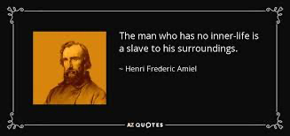On returning to the Chapter aula, first the 4 groups who dealt with ‘Inner Life’ were asked to share their 3 points. Time was provided for other comments that might reflect ‘something that we seem to have missed’. The same process was repeated for the four ‘Belonging’ groups.

Notice had obviously been taken of the ‘defections’ from our Congregation and what might help avoid this. Examples of what were suggested regarding inner life were:

Our inner life is the ID of the Passionists. It refers to all of our relational life, and we bring all of that to God. It is our inner and communal realities. Ministry can become more attractive than prayer but as was expressed, If we don’t spend time in prayer, we are preaching about the God we used to know! We need to create a safe space to share our inner life with each other. We were invited to ask ourselves: what impact is the digital world having on our capacity for healthy personal and common prayer?

**Belonging**

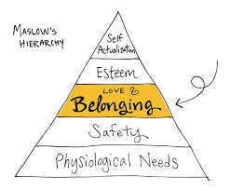There is increased awareness that to belong in the way we are called, we have to welcome, understand and appreciate difference. Community life is integral to us and our charism. We do not live like diocesan priests. Paul of the Cross called us to be apostolic companions. A nice quote was “no one falls in love with someone they don’t know”. The quality of our relationships cannot afford to be superficial and we need to avoid what fractures relationships – criticism, gossip, rumours, mercy, and any unwillingness to forgive. The strength of our belonging can be seen in how we care for the infirm and sick brothers in the community, and people can see the level of harmony we have.



Most of us are priests, but our basic vocation is that we are Passionists. With this in mind it was recommended that we place more emphasis on the life of Passionist brothers.

It was reported that the first sign of many who have left the Congregation was they wanted to use money their own way. This highlights a balance is needed so that in sharing common funds, we need to be responsible and generous exercising equity and responsibility. A person without some responsibility will ‘begin to not belong’. Students have to experience this, right from the start so they are not marginalized.

In an era of multi-culturalism. We need to learn how to live with cultural differences in both small (e.g. food) and big (acceptance) areas. Those who join need to be prepared to give, not just to ‘get’.

Our social media age has changed the way people get together (as it does in family life). It is possible that ‘everyone is watching something different in their own room’. Belonging is not just internal, but it is inside-out. We belong to the church and to the people who associate with us. Some members need psycho-sexual assistance and this has to be a part of formation. Belonging is crucial for any person, and we have to pay attention to how we can strengthen our belonging to our local community and to the Congregation.

**Leadership**

Leadership was the fourth priority of the Chapter. Four language groups (of ten) discussed this issue while the other four discussed belonging. The secretaries sent summary reports to the Chapter secretary and these were discussed in an open forum by the entire Chapter. The main points that emerged were:

A leader is a companion exercising co-leadership rather than being a solo or dominant partner. He creates cohesion through attentive listening and the sharing of responsibilities, He does have definite responsibilities and authority outlined in our Constitutions, but this must be exercised in a servant way, modelled on Jesus. What we want to avoid is authoritarianism, individualism or the unhealthy influence of strong personalities who dominate a group by substituting themselves for a leader.

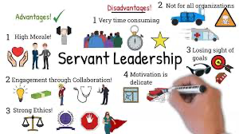Leadership is not a space of power, nor a place of privilege. It is a service for the good of the community and the church at a given time, and is not eternal! A good leader is always mindful that leadership is a gift. This helps to keep him humble. His skills may include good management, but a leader is not a manager. The leader must be able to express the vision of the community and assist them in achieving it

There needs to be induction training for new leaders and ongoing formation for all leaders. This training needs to include how to develop support structures including supervision, meeting with peers etc. It should be extended to students so they are formed for good leadership.

Sometimes community members are less supportive of leaders than is desired, because the role is burdensome at times and leaders need to learn how to deal with dissent and conflict and to offer necessary ‘corrections’. If a leader knows when to command, he must also have learned to obey!

The dark side of leadership is when members lose trust in their leader. Community leaders have a responsibility to the members of our Passionist Family associated with the community and this calls for extra skills, time and attention.

Modern communications (phones, Internet) have become more accessible and can create more demands on everyone. Individualism challenges and threatens regular fraternal community sharing. Leaders must negotiate this challenge with their brothers.

In intercultural situations there are different understandings and expectations of leadership. There can be expectations that seniority should prevail over younger men, that membership of a cultural subgroup is more important than someone’s capability. This creates a serious challenge to good leadership.

There are Provinces experiencing an unwillingness of men to take up leadership roles. Sometimes this is the result of ageing. What can be done if there is no leadership?

**New Ministeries**

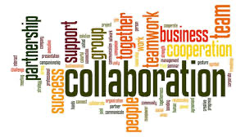‘My’ language group (of ten members) was allocated, along with three other groups to share around the issue of New Ministries. Clearly there is a belief that partnership and collaboration is critical (e.g. CP sisters and lay leaders). We are entering an era of church membership and Congregational diminishment, so laity are taking the ‘front row’. We should be involved not only in lay leadership, but the encouragement, support and empowerment of lay leaders.

Passionist life will increasingly be carried by laity, both formally and informally. We can undertake new ministries spontaneously and locally responding to the signs of the times, without losing our Passionist identity. Our first apostolate as Passionists is community life. We are called to be a sign of God’s presence and a living sign of the Kingdom of God (“A Family for All”)

There is more to ministry than sacramental life. It can be advantage to not be a priest and explore more creative options with less restrictions! Whatever we do as a Passionist we need the appropriate skills for our ministry. Provinces sometimes struggle to balance or meet their corporate ministries (e.g. parishes, retreat centres).

This can happen when the preference some men have to pursue individual ministries, many of which are significant, effective and needed.

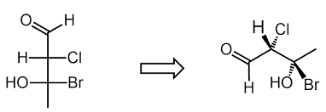There is a need for re-conversion of our structures and traditional works, to meet new ministerial needs. We also have to find the right relationship and balance between new ministries and finance (poverty v Providence). Our strength lies in difference rather than similarities, so this should guide us. The ministry of welcoming must be a feature of our ministry remembering that human closeness precedes religious conversations.

An example of new options is the digital world and new forms of communication. We should invest in formation so that younger men can undertake professional work in these areas. Several of our Vietnamese men are already working at this. 92 year old Victor Hoagland CP has created a website: <https://www.passionistspray.org/>

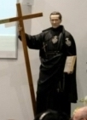There was a challenge proposed that we have to have the courage to leave a ‘comfortable’ parish to take up an alternate option to reach out to the poor and the suffering. At the same time, funding from a ‘comfortable’ parish can enable others to engage in different ministries because of the resources that can be made available. It was suggested that the Congregation promote a catechesis of prayer including new media methods and in different languages of society, to reach people on the peripheries. Paul of the Cross wanted other Passionists in his time to have the same experience as he had. This involved contemplating on the overwhelming love of God ‘seen’ in Jesus crucified and then sharing that experience. That was the mission to which he entrusted his companions.

**Passionist laity**

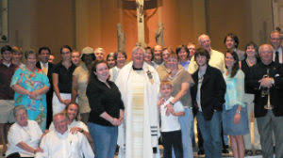The final area of feedback was provided by an international representation of lay Passionist sharing their experience with the Chapter, via Zoom. There was a very clear appreciation of our Passionist charism, a recognition that our spirituality can provide a lens for day-to-day Christian living with an attention to those who suffer and are carrying the cross, the marginalised, those lacking or seeking community for a multitude of reasons and many more. There is appreciation for the ministry and partnership with Passionists.

This partnerships is sometimes formal (such as the Passionist Companions in our Province) and includes formation in our charism. it includes co-workers in ministry and in our administration and home life, benefactors, volunteers and regular worshippers who are inspired or encouraged by our message of compassion, mercy and God’s love, and seek to live their life and enrich their relationships through incorporating this ‘message’ into their lives.

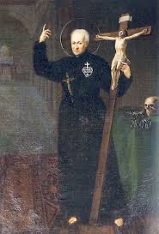

Some want to assist the professed as Paul of the Cross would express it, “by using every means possible’. Some have been partners, companions or associates for many years. On the other hand it was exciting to see and hear one of our Companions from Vietnam share (in English) his experience.



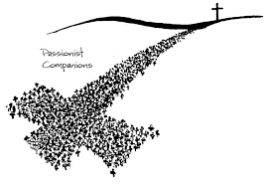There is a clear recognition among our lay partners, that they and we, need and want to deepen these partnerships. There are formal and informal associations through the entire Congregation, and we were touched by the level of commitment, the depth of Passionist spirituality and the desire to continue developing these realities. Certainly we need to continue to provide in various ways, both formal and informal sharing of our charism.

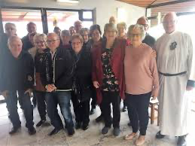Unfortunately the time zones made it most difficult for Australia (2.00am) and New Zealand (4.00am) so we did not ask anyone from New Zealand to participate. We did ask Gerard Daly and Tina Minichilli. Gerard advised us that he had not received the link by 1.30am, so he did the sensible thing and went to bed. That was most unfortunate, particularly because Gerard’s experience and leadership of Passionist Companions spans three countries in our Province. Tina was excellent and we were most grateful for her effort and her sharing.

**Sunday 13th October**

Because we had a two-day PASPAC meeting on October 1st-2nd, today is the first free day for us this month. It is a beautiful sunny day (24 degrees). I’ve been able to do a fair amount of work writing up this news in the morning. Australian Bishops (Tim Costelloe (Perth), Patrick O’Reagan (Adelaide) Shane McKinley (Sandhurst), and Archbishop Paul Martin from Wellington, NZ came for lunch.

**Synago**

One of the Italian Passionists, Marko Pasquale, has deigned an IT system that allows for a virtually paperless Chapter. All documents, reports and messages are sent to the system (named Synago) in the three Chapter languages (Italian, Spanish and English). They cannot be accessed by anyone other than those authorized (Chapter members or assistants).

The number of documents is piling up – 98 as of Saturday morning October 12th and there will be more by Monday morning. Perhaps 15 of these more lengthy documents had been sent for us to read before we got to Rome.

**Walking**

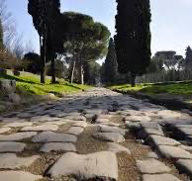Because our programme has been so full (sessions start at 8.00am and finish with 7.00pm Mass before 8.00pm dinner) it has been difficult to find much more that 60-75 minutes to go for a walk after 1.00pm lunch before we resume at 3.15pm or 3.30pm. I’ve usually managed by skipping lunch and just taking a small filled roll. Fortunately I know my way around so I can head off in a different direction each day. My plan this afternoon is to head out on the Via Appia Antica, because there is almost no traffic out there on Sundays. I have done this a few times before. It is 2kms from here at Sts John and Paul’s to get to the starting point! The road was constructed in 312BCE and it passes the Quo Vadis church, several catacombs, the tomb of Cecilia Metella the ancient racetrack of Maxentius, and many other sights and monuments. <https://romesite.com/via-appia-antica.html>

Because I have gathered so much information from our reports and interactions, I will ask Erick to send this news out on Monday. I should have more information (but not this detailed) by Thursday, which is the day we elect a new General. Erick can pass on that news, and the membership of the new General Council which elected on Friday (Rome time).

 I will conclude by mentioning that having looked up the results, I saw that Erick came seventh in the Melbourne marathon on Sunday, in the time of 2 hours 21 minutes and 6 seconds. This is slightly faster than last year and a personal best. It is a great achievement given he suffered a severe injury several weeks ago that disrupted his training.